C++ EXTRA NOTES (DATATYPES STORAGE FORMATS) (1)
1. Alphanumeric Codes Kya Hain?
Computer sirf numbers (0, 1) samajhta hai, lekin humein text, symbols aur numbers handle karne hote hain. Inko computer ki bhasha mein convert karne ke liye jo "Translator" ya codes use hote hain, unhe Alphanumeric Codes kehte hain.

2. ASCII (American Standard Code for Information Interchange)
Ye sabse zyada use hone wala standard hai.
- Size: Asli ASCII sirf 7 bits ka hota hai ($2^7 = 128$ characters).
- Extended ASCII: Aaj kal hum 8 bits wala ASCII use karte hain jisme 256 characters hote hain.
- Logic: Har character ka ek fixed number hota hai.
  - 'A' = 65 (Binary: 01000001)
  - 'a' = 97 (Binary: 01100001)
  - '0' = 48 (Note: Keyboard wala '0' aur integer wala 0 alag hote hain).

3. EBCDIC (Extended Binary Coded Decimal Interchange Code)
- Isko IBM ne banaya tha apne mainframe computers ke liye.
- Ye bhi 8-bit ka code hai.
- Point to remember: ASCII aur EBCDIC aapas mein compatible nahi hain. Yani ASCII ka 65 EBCDIC mein kuch aur ho sakta hai. Ye aaj kal sirf purane IBM systems mein hi milta hai.

4. UNICODE (The Global Standard)
ASCII ki sabse badi problem ye thi ki wo sirf English characters handle kar pata tha. Hindi, Chinese ya Emojis ke liye ASCII chota pad gaya. Isliye UNICODE aaya.
- Purpose: Duniya ki har language ke har character ko ek unique number dena.
- UTF-8 (Unicode Transformation Format): Ye sabse famous encoding hai.
  - Iski khasiyat ye hai ki ye Variable Length ka hota hai.
  - English akshar 1 byte (8-bit) mein store ho jayenge, lekin complex languages ya emojis 2, 3 ya 4 bytes le sakte hain.
  - Ye ASCII ke saath compatible hai.

5. Integer vs Character Storage (Extra Concept for You)
Video mein sir ne ek bohot important baat chhedi: jab tum keyboard se 4 dabate ho, toh computer use integer 4 nahi, balki ASCII code 52 samajhta hai.
- Char '4': Memory mein ASCII code 52 store hoga.
- Int 4: Memory mein binary 0100 store hoga.
Toh jab hum C++ mein char c = '4'; likhte hain, toh computer background mein 52 ke saath khel raha hota hai.

6. Short Summary Table
Code Type | Bits | Characters | Main Use
ASCII | 7 or 8 | 128 or 256 | PC, Internet, Programming
EBCDIC | 8 | 256 | IBM Mainframes
UNICODE | 8 to 32 | Millions | All languages, Emojis

C++ EXTRA NOTES (DATATYPES STORAGE FORMATS) (2)
1. Numbers ke Types (Representations)
Computer mein numbers do tarah ke hote hain:
- Unsigned Integers: Sirf positive numbers (jaise 0, 1, 2, ...). Isme koi sign bit nahi chahiye hoti.
- Signed Integers: Positive (+) aur Negative (-) dono numbers. Computer ko batana padta hai ki number negative hai ya nahi.
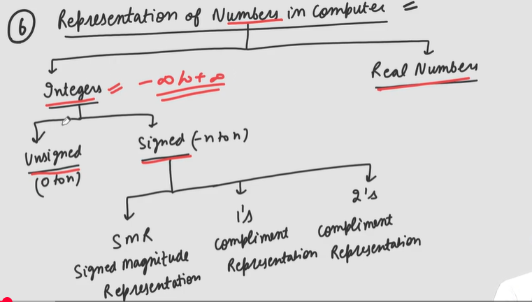
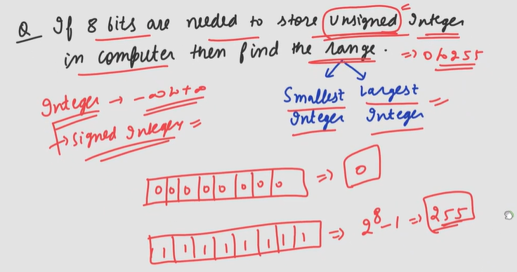
2. Signed Representation ke Tareeke
Computer mein signed numbers ko dikhane ke liye 3 main tareeke (Representations) use hote hain:
- Sign-Magnitude Representation (SMR):
  - Sabse purana aur simple tareeka.
  - Isme sabse pehli bit (MSB - Most Significant Bit) sign ke liye hoti hai.
    - 0 ka matlab Positive (+)
    - 1 ka matlab Negative (-)
  - Baki bits number ki value (magnitude) batati hain.
  - Problem: Isme do tarah ke zero hote hain (+0 aur -0), jo math mein confusion paida karte hain.
- 1's Complement Representation:
  - Isme negative number nikalne ke liye positive number ki saari bits ko Flip (ulta) kar dete hain. (0 ko 1, aur 1 ko 0).
  - Isme bhi do tarah ke zero (+0 aur -0) ki problem rehti hai.
- 2's Complement Representation (Sabse Important):
  - Modern computers yahi use karte hain.
  - Iska formula: $2's \text{ Complement} = (1's \text{ Complement}) + 1$.
  - Iska sabse bada fayda ye hai ki isme zero sirf ek hi hota hai, aur computer math (Addition/Subtraction) bohot aasaani se kar leta hai.

3. MSB ka Khel (Sign Bit)
- Agar hum 8-bit memory use kar rahe hain, toh:
  - 7 bits number store karne ke liye bachti hain.
  - 1 bit (MSB) ye batati hai ki number sign kya hai.
- Formula for Range: Agar tumhare paas n bits hain:
  - Unsigned ki range: 0 se 2^n - 1.
  - Signed ki range (approx): -2^{n-1} se +2^{n-1} - 1.

4. Ek Solid Rule (Jo sir ne bataya)
Video mein ek bohot bada point hai: "Positive numbers ke liye teeno representations (SMR, 1's, aur 2's complement) ekdum SAME hote hain."
Khel tab badalta hai jab number Negative ho jata hai.
5. Summary Table (For your notes)
Representation | MSB=0 | MSB=1 | Double Zero Problem?
SMR | Positive | Negative | Haan
1's Complement | Positive | Inverse of bits | Haan
2's Complement | Positive | (1's comp) + 1 | Nahi

